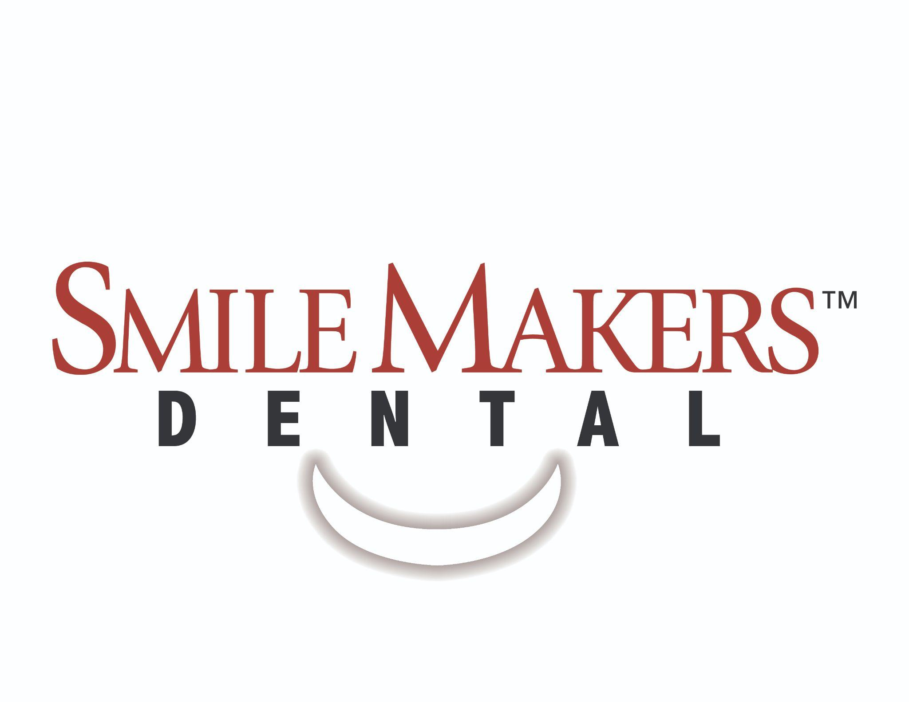

Media Release Form

I, _________________________________________________________, consent to be photographed, recorded, and/or published by SmileMakers Dental for the use of Social Media Promotion. I further authorize that media taken be published for any other purpose and in any other form.

Patient, Parent, Guardian
X______________________________________________________________ Date__________________________

