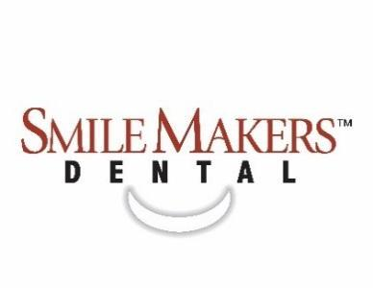

675 Yellowstone Ave. Pocatello, Idaho 83201
Phone: (208) 478-5700 Fax: (208) 269-7164
Patient Application

Date _____/_____/_____ Name ___________________________________________________________________________________
First Middle Initial Last

Gender □ Male □ Female Birthdate _____/_____/_____ SSN ________ - ________ - _________
Status □ Single □ Married □ Child □ Other _______________
Address _________________________________________________________________________________________________________
Street City State Zip Code
Email ____________________________________________________________________________________________________________
Preferred Phone (____)__________ □ Home □ Mobile Alternate Phone (____)_________ □ Home □ Mobile

Person responsible for account if other than yourself:
Name: __________________________________________ Birthdate: _____/_____/_____ SSN: ________ - ________ - _________
Billing Address: __________________________________________________________________________________________________
Contact Phone: (_____) _______________________ Relationship to patient: ___________________________________________
Employer: ______________________________________________ Phone Number: (_____) _________________________________
If patient is a minor: Mother’s Birthdate: _____/_____/_____ Father’s Birthdate: _____/_____/_____
Primary Insurance:

Insurance Company: ______________________________________________________________________________________________
Insured’s name: ______________________________________ Relation to patient: _______________________________________
Insured’s Address: ________________________________________________________________________________________________
Group Name: ____________________________________________ Group Number: ________________________________________
Member ID/Policyholder SSN*: ___________________________________________ *Required for insurance verification
Employer: _________________________________________________ Date employed: _____________________________________
Secondary Insurance (if applicable):

Insurance Company: ______________________________________________________________________________________________
Insured’s name: ______________________________________ Relation to patient: _______________________________________
Insured’s Address: ________________________________________________________________________________________________
Group Name: ____________________________________________ Group Number: ________________________________________
Member ID/Policyholder SSN*: ___________________________________________ *Required for insurance verification
Employer: _________________________________________________ Date employed: _____________________________________

Dental History
Former Dentist: ___________________________________________________________ Date of last visit_____/______/_______
How often do you floss? □ Daily □ Weekly □ Rarely How often do you brush? □ 2x a day □ 1x a day

Select any of the following that apply to you:

□ Rheumatic Fever | □ Grinding teeth | □ Sensitivity to heat
□ Bleeding gums | □ Loose teeth or broken fillings | □ Sensitivity to sweets
□ Clicking or popping jaw | □ Periodontal treatment | □ Sensitivity when biting
□ Food collection between teeth | □ Sensitivity to cold | □ Sores or growths in your mouth

Medical History

Emergency Contact: ________________________ Phone: (____) __________________ Relationship: _______________________
Physician ______________________________________________________________________ Date of last visit _____/_____/_____
Current Medications:______________________________________________________________________________________________
Allergies: _________________________________________________________________________________________________________
Are you pregnant? □ Yes □ No Nursing? □ Yes □ No Taking birth control pills? □ Yes □ No

Select any of the following the apply to you:

□ AIDS | □ Congenital Heart Lesions | □ Hepatitis | □ Rheumatic Fever
□ Anemia | □ Cortisone Treatments | □ Hernia Repair | □ Scarlet Fever
□ Arthritis, Rheumatism | □ Cough, Persistent | □ High Blood Pressure | □ Shortness of Breath
□ Artificial Heart Valves | □ Cough up blood | □ HIV Positive | □ Skin Rash
□ Artificial Joints | □ Diabetes | □ Jaw Pain | □ Stroke
□ Asthma | □ Epilepsy | □ Kidney Disease | □ Swelling Feet or Ankles
□ Back Problems | □ Fainting | □ Liver Disease | □ Thyroid Problems
□ Bleeding Abnormally | □ Glaucoma | □ Mitral Valve Prolapse | □ Tobacco Habit
□ Blood Disease | □ Headaches | □ Nervous Problems | □ Tonsillitis
□ Cancer | □ Heart Murmur | □ Pacemaker | □ Tuberculosis
□ Chemical Dependency | □ Heart Problems | □ Psychiatric Care | □ Ulcer
□ Chemotherapy | Describe ______________ | □ Radiation Treatment | □ Venereal Disease
□ Circulatory Problems | □ Hemophilia | □ Respiratory Disease | □ Other _________________

Have you ever taken any of these medications?
Diet Medications: □ Dexfenfluramine □ Fen-Phen □ Pondimin □ Redux
Blood Thinners: □ Coumadin □ Warfarin
Other: □ Levoxyl □ Synthroid

Are you allergic to any of the following?
□ Latex □ Penicillin/Amoxicillin □ Tetracycline □ Aspirin □ Dental Anesthetics

To the best of my knowledge, the above information is complete and correct. I understand that it is my responsibility to inform my doctor if I, or my minor child, ever have a change in health.

___________________________________________________________________________________________ Date _____/_____/_____
Signature of Responsible Party

_________________________________________________________________________ Relationship to patient: _________________
Please print name of Responsible Party
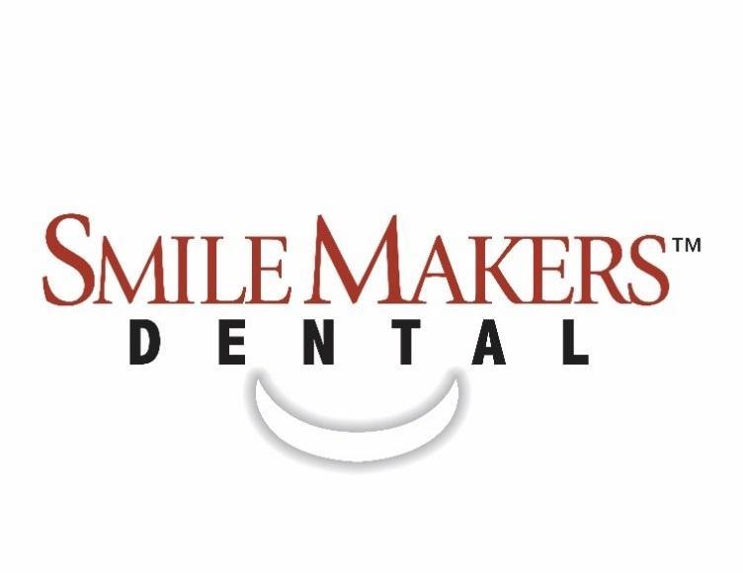
CONSENT FOR TREATMENT

I, the undersigned, hereby authorize the doctor to take radiographs, study models, photographs or any other diagnostic aids he/she deems appropriate to make a thorough diagnosis of my dental needs. I also authorize the doctor to perform any and all necessary forms of treatment, medication and therapy that may be indicated. I authorize and consent that the doctor employs any such assistance as he/she deems appropriate.

I further authorize the release of any information, including the diagnosis, radiographs and records of any treatments or examinations rendered to my insurance company, consulting professionals or others who may request my records.

I understand that I am personally responsible for payment of all fees for dental services provided in this office for me or my dependents, regardless of insurance coverage. Breach of this responsibility carries the penalty of compensating the practice for any related attorneys and collection fees. In the event that a check is returned, there will be a $30.00 return-check-fee applied to your balance. I understand that payment is due when services are rendered. Any other arrangements for payment must be made before treatment begins.

I understand that in the event I need to cancel or reschedule my appointment, I must do so within 24 business hours to avoid a $25 charge.

___________________________________________________________________________________________ Date _____/_____/_____
Signature of Responsible Party

_________________________________________________________________________ Relationship to patient: _________________
Please print name of Responsible Party
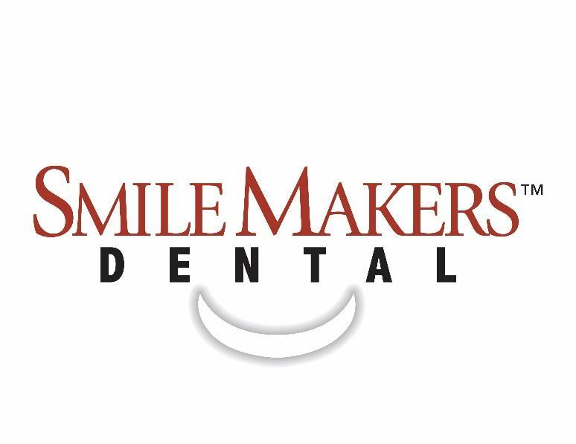

ELECTRONIC COMMUNICATION CONSENT FORM
We, at SmileMakers Dental of Pocatello, take your privacy seriously. While we have the option to communicate with our patients in several different forms, we understand that some of these communication methods are not ideal for everyone. Please indicate below which methods work best for you.

Select yes or no for EACH option How did you hear about us?
Mail ⬜ Yes ⬜ No Social Media ⬜
Phone Call ⬜ Yes ⬜ No Google ⬜
Text Message ⬜ Yes ⬜ No Round Tuit ⬜
Voicemail ⬜ Yes ⬜ No Other ____________________ ⬜
Email ⬜ Yes ⬜ No Friend/Family (If yes, who?) ⬜
___________________________

*By signing below, I authorize SmileMakers Dental of Pocatello to contact me using the methods selected above. I understand that I may make changes to these preferences at any time by contacting the front desk.

___________________________________________________________________________________________ Date _____/_____/_____
Signature of Responsible Party

_________________________________________________________________________ Relationship to patient: _________________
Please print name of Responsible Party

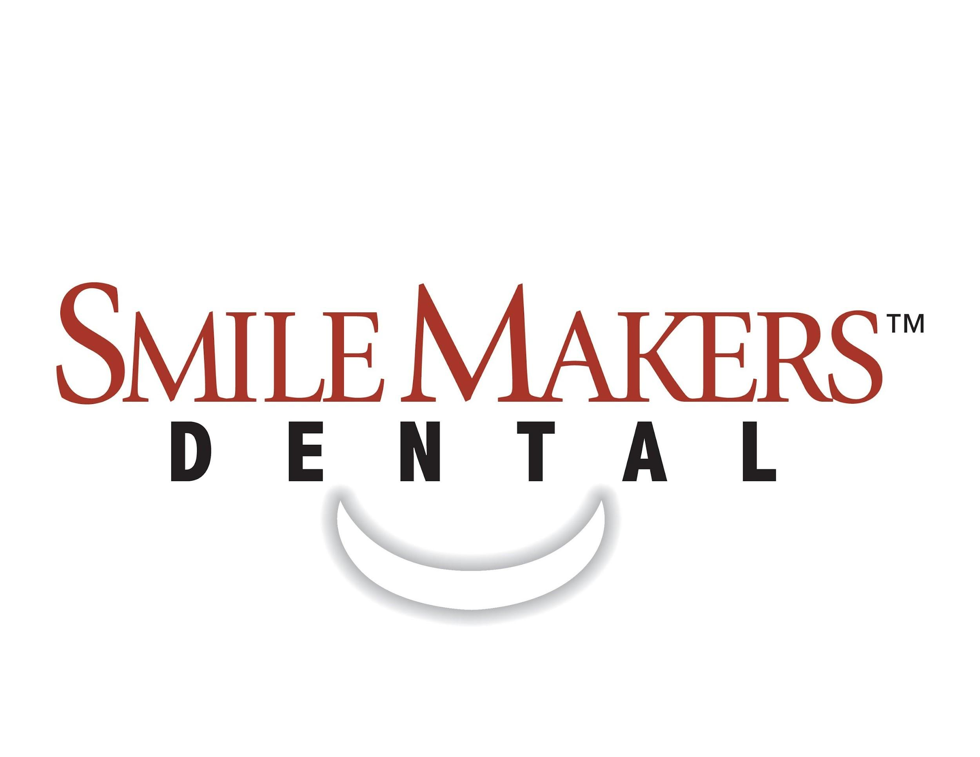

HIPAA PRIVACY FORM

Acknowledgement of Receipt of Notice of Privacy Practices
**You May Refuse to Sign This Acknowledgement**
Purpose: This form is used to obtain acknowledgement of receipt of our Notice of Privacy Practices or to document our good faith effort to obtain acknowledgement.

Choose one of the following:
□ I choose to opt-out of receiving the full copy of this office’s Notice of Privacy Practices.
□ I request a copy of this office’s Notice of Privacy Practices.

_________________________________________________
Print Patient Name

______________________________________________________________________________________________
List all persons who can receive private information on your behalf

__________________________________________________________________________________________ Date: _____/_____/_____
Signature of Responsible Party

____________________________________________________________________________ Relation to patient: _________________
Please print name of Responsible Party

For Office Use Only
We have tried to obtain written acknowledgement of receipt of our Notice of Privacy Practices, but acknowledgement could not be obtained because:

□ Individual refused to sign

□ Communications barriers prohibited obtaining the acknowledgement

□ An emergency prevented us from obtaining acknowledgement

□ Other (Please Specify) ______________________________________

Staff Initials _______

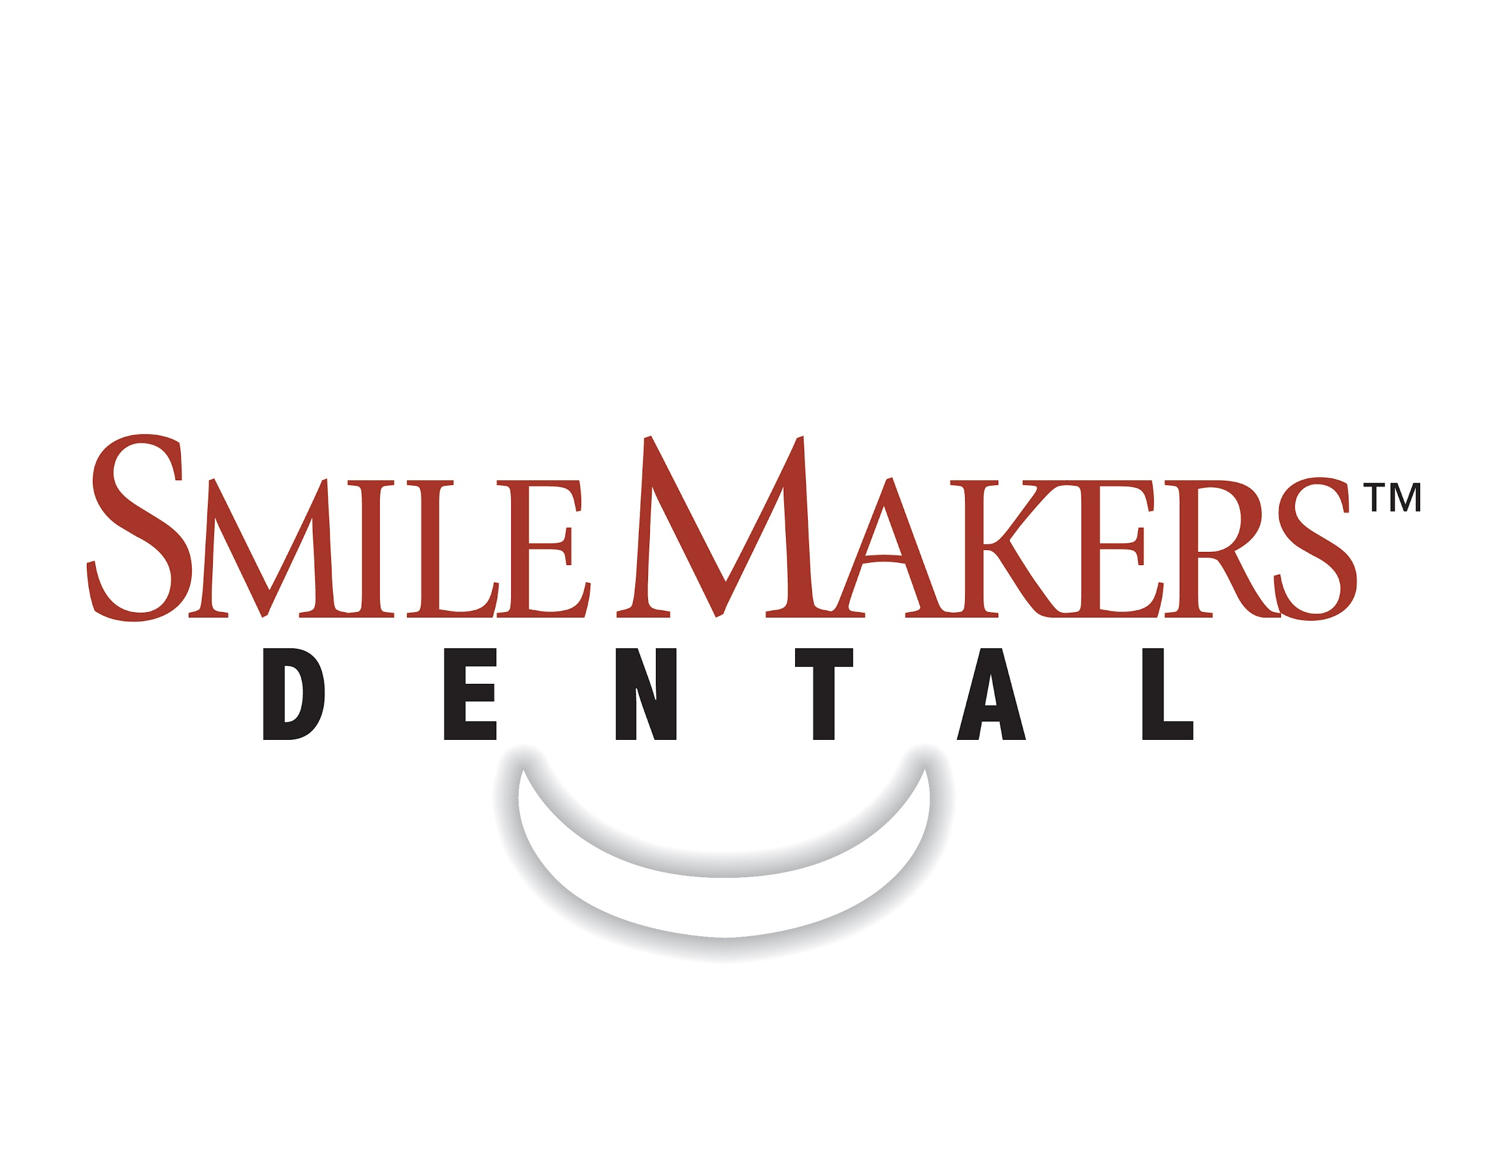

Smile Analysis

Please mark and X by any statement you agree with:
- I wish the color of my teeth were whiter.
- I wish I had a bigger smile.
- I think some of my teeth are too large or too small.
- I wish my teeth were straighter.
- I think my gums show too much when I smile.
- I think there is too much space between some of my teeth.
- I don’t know all of the options available to enhance my smile.
- My concerns with fees have prevented me from enhancing my smile.

How would you best describe your feelings about past dental office experiences?
- Excellent
- Good
- Satisfactory
- Poor
- Very Poor

What can we do to make this the best experience for you?
____________________________________________________________________________________________________________________________________________________________

Is there anything else we should know?
________________________________________________________________________________________________________________________________________________________________________________________________________________________________________________________________________________________________________________________

